Prerequisites for ROS Driver Package:‌
(1) Ubuntu 16/Ubuntu 18/Ubuntu 20 system
(2) Ubuntu installed with ROS1
(3) Computer platform: x86_64, AMD
Note: If the ARM architecture fails to recognize the CAN adapter, please contact after-sales support to install the PCAN driver. It is recommended not to use a virtual machine but to install Ubuntu directly.

- ‌Check CAN Functionality‌
1.1 Connect the CAN adapter to the computer's USB port.
1.2 Open the terminal and enter the command lsusb. If the output includes the following information, the CAN adapter is functioning properly.

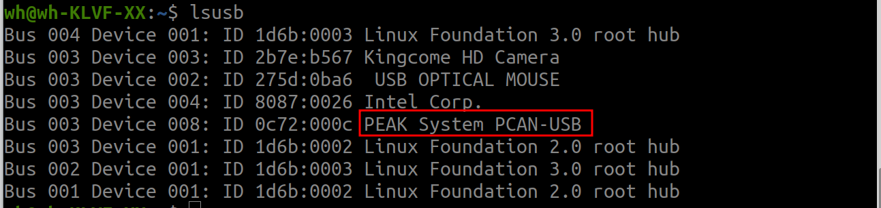
- ‌Automatic Startup Configuration‌
Note: Not all computers can achieve this successfully; there may be differences across brands.
2.1 Check if the /etc/ directory contains an rc.local file. If not, execute sudo cp rc.local /etc. If the file exists, add the following content above the exit 0 line in rc.local and save:

sleep 2
sudo ip link set can0 type can bitrate 500000
sudo ip link set can0 up
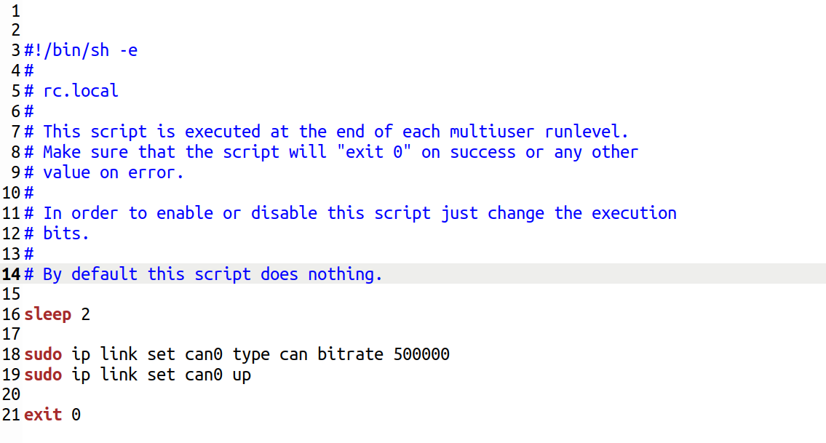
2.2 Before booting or restarting, ensure the CAN adapter is connected to the industrial computer's USB port.

2.3 A solid green light on the CAN adapter indicates successful setup.

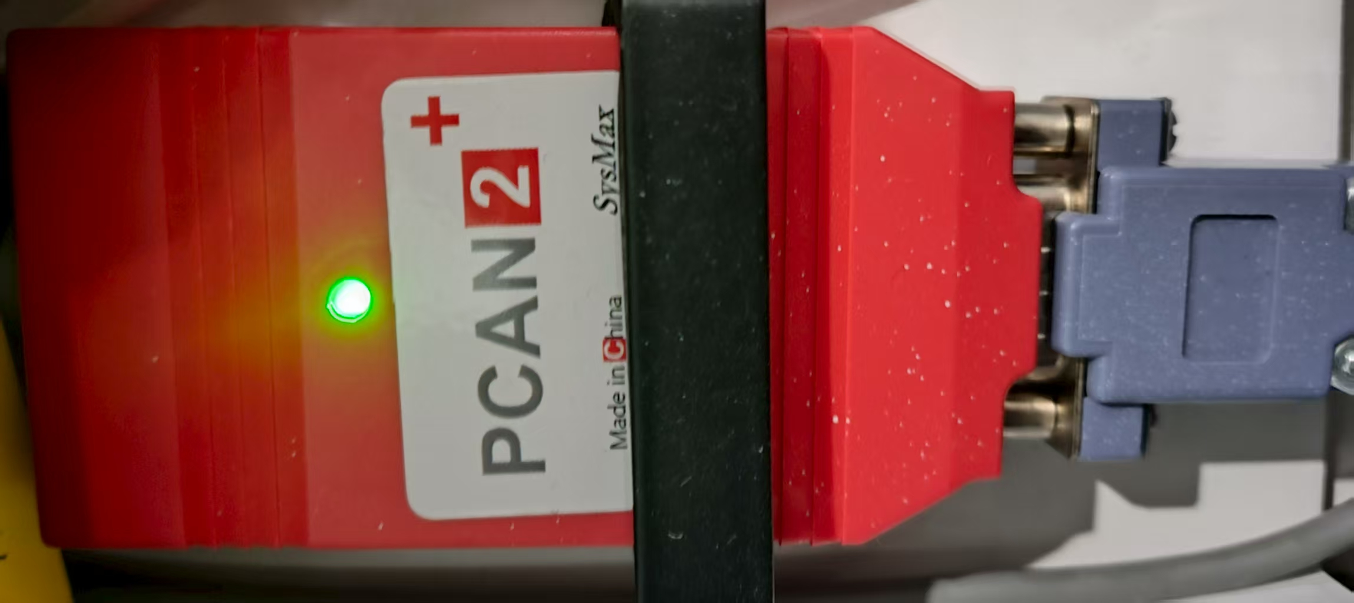

- Manual Startup Configuration‌
3.1 After reconnecting the CAN adapter, execute the following commands to enable it:
sudo ip link set can0 type can bitrate 500000
sudo ip link set can0 up
Note: Verify if your computer assigns the can0 interface (use ifconfig command. If the command is not found, install it as prompted). Built-in CAN computers may not necessarily assign can0.

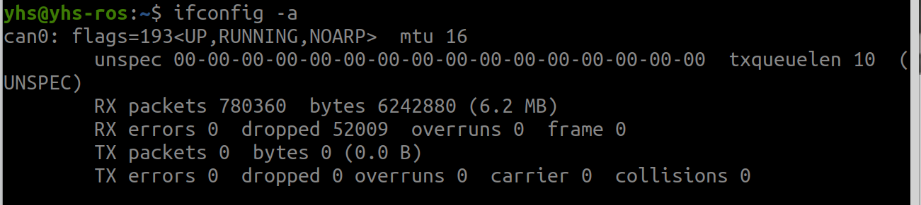

3.2 A solid green light on the CAN adapter indicates successful setup.

- ‌Communication Testing‌
  - Connect the chassis CAN cable to the CAN adapter: chassis red wire to CANH and chassis black wire to CANL.

  - After proper connection, the CAN adapter's green light should blink. If it doesn't, check if the chassis is powered and if the CAN cables are correctly connected. Note: Directly connect the chassis CAN cable to the CAN adapter first to ensure normal communication before using extension cables.

4.3 After installing can-utils (sudo apt-get install can-utils), open a terminal and enter candump can0 to view the data received by the CAN adapter from the chassis.
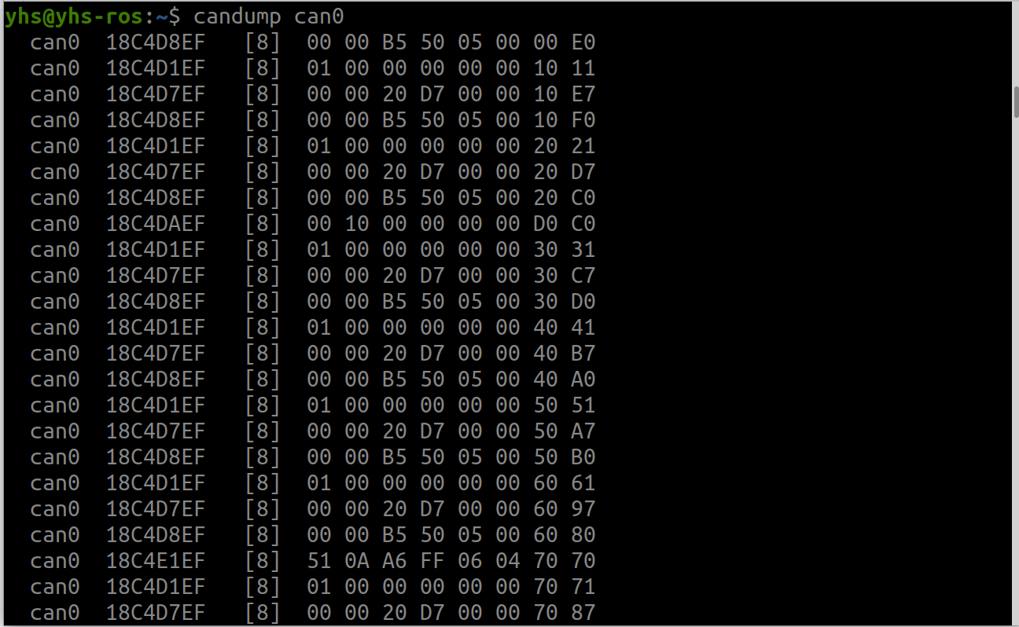

- For specific usage of the ROS driver package, refer to the separate documentation.

